***Post on Tuesday, March 30***

This coming Thursday, April 8, is Go Blue Day to acknowledge Child Abuse Prevention Month in April! Make sure to join all of us and show your spirit by wearing blue. Wear Blue anywhere – to work, to school, a community event, the gym and even at home. Invite your friends, family, students, co-workers or even your entire office to Wear Blue too. Do not forget to share a photo with us!

*Use graphic below (it’s attached to the email):*

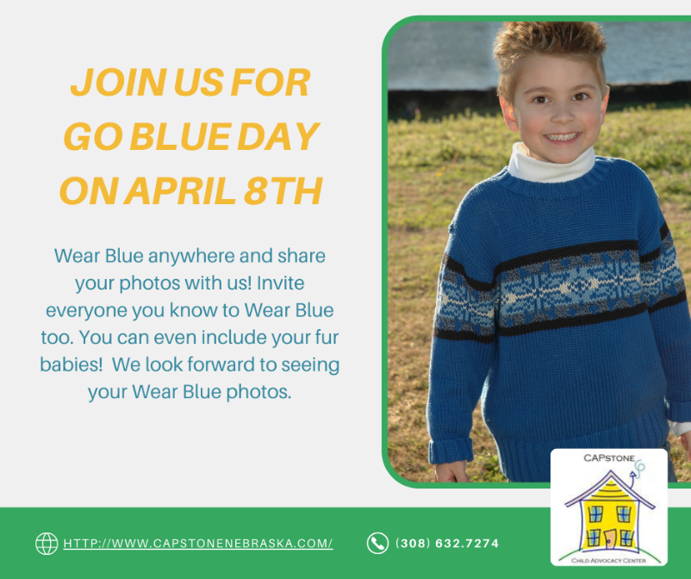

***Post on Thursday, March 31***

Last year, there were many victims of child abuse and neglect in Nebraska - Now more than ever, we must all come together to better protect and support the children in our community. What will you do to make a difference in a child's life?

*Use graphic below (it’s attached to the email):*

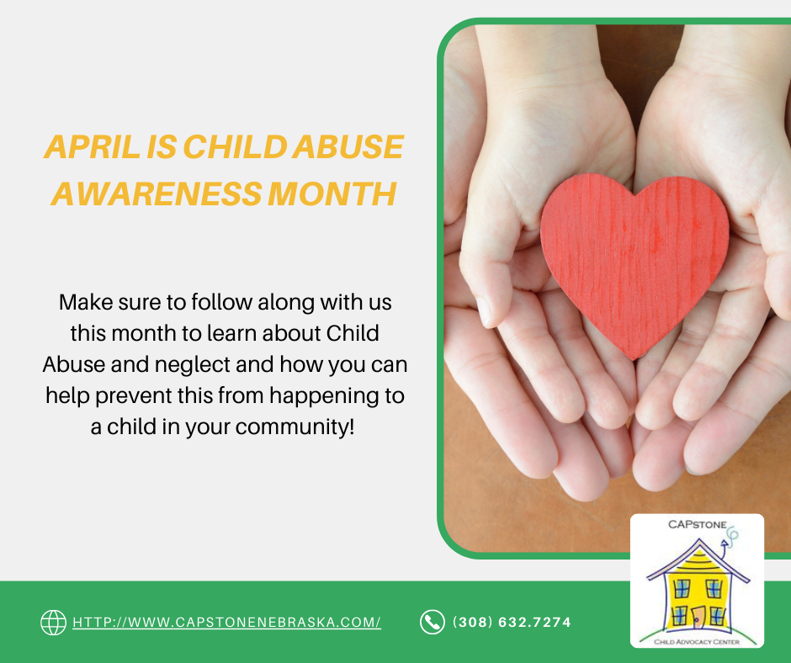

***Post on Friday, April 1***

Throughout April and indeed throughout the year, we encourage individuals, organizations and communities to work together to build awareness of abuse and neglect in our world, and prevent child abuse and neglect by strengthening and supporting families.

*Use graphic below (it’s attached to the email):*

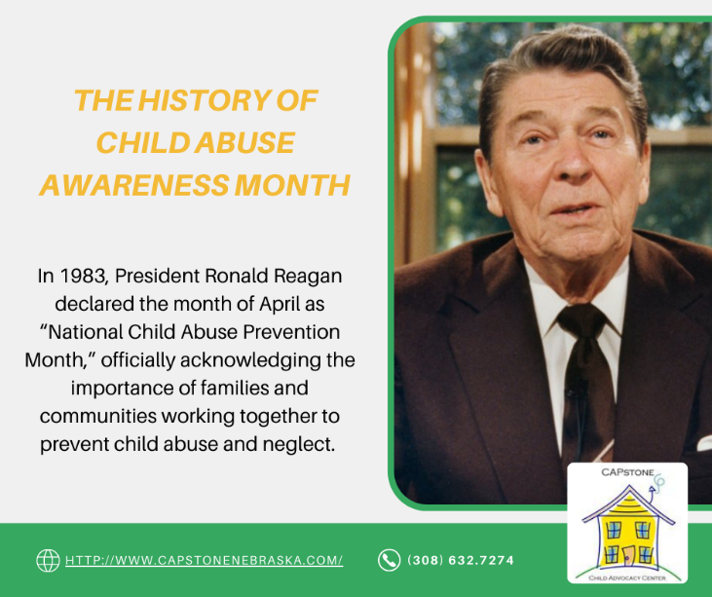

***Post on Thursday, April 8***

Today is Go Blue Day to acknowledge Child Abuse Prevention Month in April! In honor of this special day, we will be selling pinwheels at CAPstone for $1.00 and giving away cookies! Show your spirit by stopping by and by wearing blue!

*Use graphic below (it’s attached to the email):*

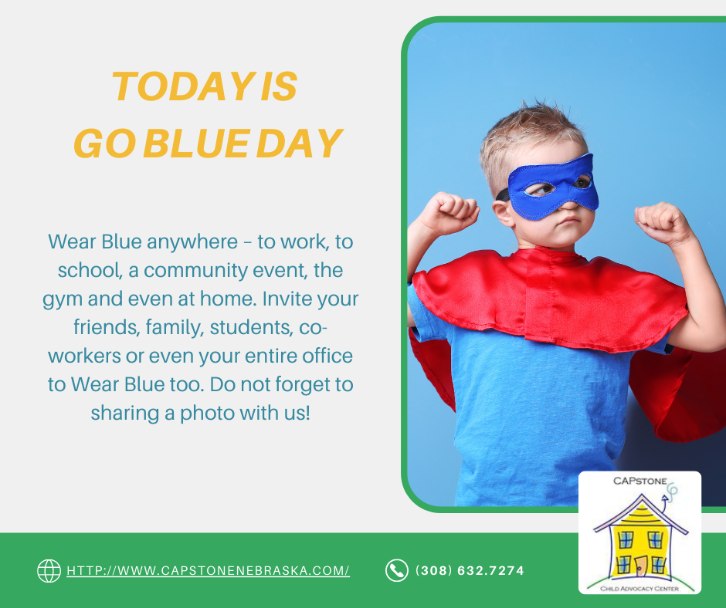

***Post on Thursday, April 15***

Though there was a pandemic in 2020, child abuse did not stop. We helped 499 children at our center. How did we help those children and their families? We performed 474 forensic interviews, 19 medical exams and referred 162 children for mental health counseling. For more on our services visit: <http://www.capstonenebraska.com/>

*Use graphic below (it’s attached to the email):*

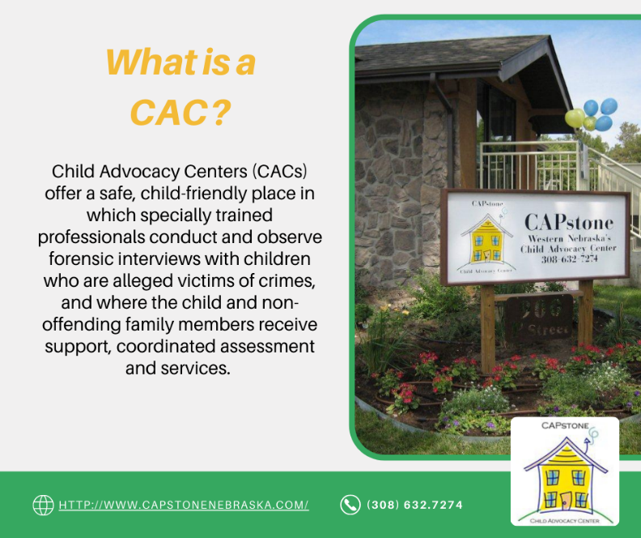

***Post on Thursday, April 22***

Since the pandemic began, reports of suspected child abuse & neglect have decreased, but that doesn’t mean abuse and neglect are occurring less. Due to shelter-in-place, continued social distancing and the lengthened distance learning, children have less contact with trusted adults outside their homes who can report suspected abuse.

*Use graphic below (it’s attached to the email):*

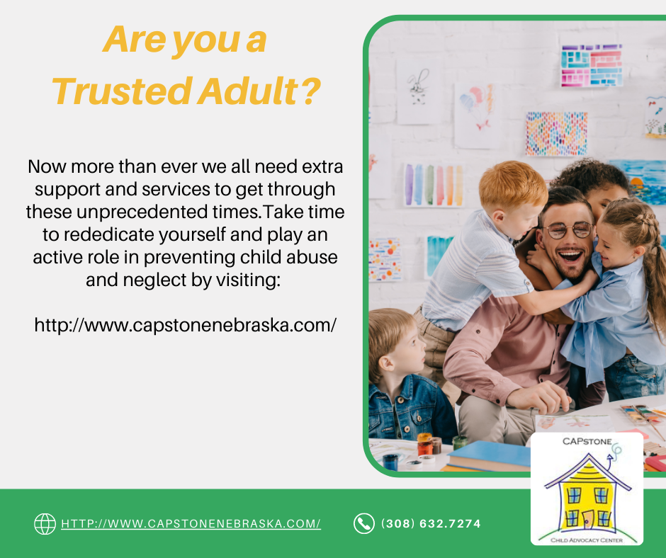

***Post on Thursday, April 29***

Children suffering from abuse or neglect often show physical and behavioral signs. Recognizing those signs can help families overcome the underlying issues of maltreatment. There are four major types of child maltreatment: Neglect, Physical Abuse, Sexual Abuse and Emotional Abuse. Here are some examples of signs to look for. If you see something, say something.

*Use graphic below (it’s attached to the email):*

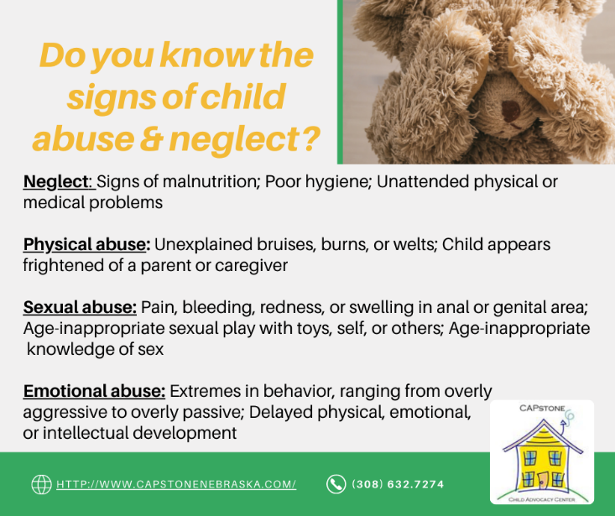

***Post on Thursday, April 30***

In the state of Nebraska, **EVERYONE** is a mandated reporter. This means physicians, medical institutions, nurses, school employees, social workers or **any other person** who has reasonable cause to believe that a child has been subjected to abuse or neglect is required by law to make a report to the CPS Hotline and/or Law Enforcement. You do not have to be certain that abuse has occurred to make a report.

*Use graphic below (it’s attached to the email):*

